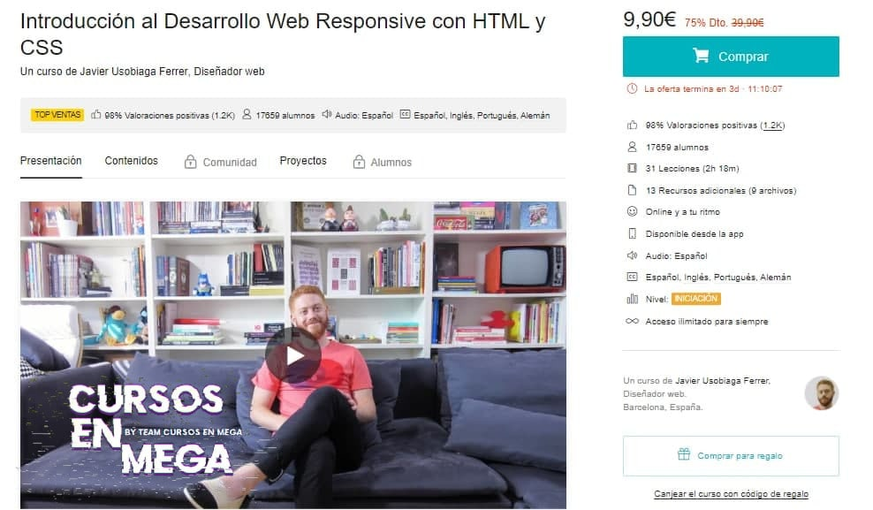

𝐈𝐧𝐭𝐫𝐨𝐝𝐮𝐜𝐜𝐢ó𝐧 𝐚𝐥 𝐃𝐞𝐬𝐚𝐫𝐫𝐨𝐥𝐥𝐨 𝐖𝐞𝐛 𝐑𝐞𝐬𝐩𝐨𝐧𝐬𝐢𝐯𝐞 𝐜𝐨𝐧 𝐇𝐓𝐌𝐋 𝐲 𝐂𝐒𝐒  
𝙰𝚙𝚛𝚎𝚗𝚍𝚎 𝚕𝚘𝚜 𝚏𝚞𝚗𝚍𝚊𝚖𝚎𝚗𝚝𝚘𝚜 𝚍𝚎𝚕 𝙳𝚎𝚜𝚊𝚛𝚛𝚘𝚕𝚕𝚘 𝚆𝚎𝚋 𝙵𝚛𝚘𝚗𝚝𝚎𝚗𝚍  
¡𝙻𝚕𝚎𝚟𝚊 𝚝𝚞 𝚍𝚒𝚜𝚎ñ𝚘 𝚊𝚕 𝚗𝚊𝚟𝚎𝚐𝚊𝚍𝚘𝚛! 𝙴𝚗 𝚎𝚜𝚝𝚎 𝚌𝚞𝚛𝚜𝚘, 𝙹𝚊𝚟𝚒𝚎𝚛 𝚄𝚜𝚘𝚋𝚒𝚊𝚐𝚊 𝚝𝚎 𝚎𝚗𝚜𝚎ñ𝚊𝚛á 𝚊 𝚌𝚛𝚎𝚊𝚛 𝚙á𝚐𝚒𝚗𝚊𝚜 𝚠𝚎𝚋 𝚌𝚘𝚗 𝚕𝚊𝚜 𝚑𝚎𝚛𝚛𝚊𝚖𝚒𝚎𝚗𝚝𝚊𝚜 𝚖á𝚜 𝚏𝚞𝚗𝚍𝚊𝚖𝚎𝚗𝚝𝚊𝚕𝚎𝚜: 𝙷𝚃𝙼𝙻 𝚢 𝙲𝚂𝚂. 𝙰𝚙𝚛𝚎𝚗𝚍𝚎𝚛á𝚜 𝚊 𝚎𝚜𝚌𝚛𝚒𝚋𝚒𝚛 𝚝𝚞 𝚙𝚛𝚘𝚙𝚒𝚘 𝚌ó𝚍𝚒𝚐𝚘 𝚢 𝚌𝚊𝚖𝚋𝚒𝚊𝚛á𝚜 𝚝𝚞 𝚏𝚘𝚛𝚖𝚊 𝚍𝚎 𝚟𝚎𝚛 (𝚢 𝚍𝚎 𝚍𝚒𝚜𝚎ñ𝚊𝚛) 𝚕𝚊 𝚠𝚎𝚋, 𝚎𝚗𝚝𝚎𝚗𝚍𝚒𝚎𝚗𝚍𝚘 𝚌ó𝚖𝚘 𝚏𝚞𝚗𝚌𝚒𝚘𝚗𝚊 𝚙𝚘𝚛 𝚍𝚎𝚗𝚝𝚛𝚘 𝚢 𝚌ó𝚖𝚘 𝚍𝚒𝚜𝚎ñ𝚊𝚛 𝚞𝚗𝚊 𝚠𝚎𝚋 𝚛𝚎𝚜𝚙𝚘𝚗𝚜𝚒𝚟𝚎 𝚙𝚊𝚛𝚊 𝚚𝚞𝚎 𝚜𝚎𝚊 𝚖á𝚜 𝚎𝚏𝚎𝚌𝚝𝚒𝚟𝚊. 𝚈 𝚜𝚒 𝚎𝚕 𝚍𝚒𝚜𝚎ñ𝚘 𝚗𝚘 𝚎𝚜 𝚕𝚘 𝚝𝚞𝚢𝚘, 𝚎𝚜𝚝𝚎 𝚌𝚞𝚛𝚜𝚘 𝚙𝚞𝚎𝚍𝚎 𝚜𝚞𝚙𝚘𝚗𝚎𝚛 𝚞𝚗𝚊 𝚋𝚞𝚎𝚗𝚊 𝚋𝚊𝚜𝚎 𝚙𝚊𝚛𝚊 𝚌𝚘𝚖𝚎𝚗𝚣𝚊𝚛 𝚎𝚗 𝚎𝚕 𝚖𝚞𝚗𝚍𝚘 𝚍𝚎𝚕 𝙳𝚎𝚜𝚊𝚛𝚛𝚘𝚕𝚕𝚘 𝚆𝚎𝚋 𝙵𝚛𝚘𝚗?

https://drive.google.com/drive/folders/1zNxDQPuDJXO-PKUvljYazxZmWIpLvICI